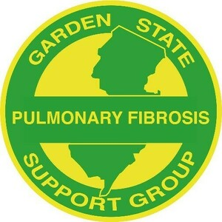
a 5013c Charitable Organization
www.gardenstatebreathe.org
gspfsgbreathe@gmail.com

Garden State Pulmonary Fibrosis Support Group
Meeting Agenda
Wednesday, October 27, 2021 @ 7 p.m. via Zoom

CALL TO ORDER

MOMENT OF SILENCE FOR MEMBERS WHO HAVE PASSED AWAY

VISION
To be a resource to those diagnosed with Pulmonary Fibrosis in order to educate patients and others about the disease and options for treatment; to offer hope, comfort and knowledge to patients, caregivers and their families and to raise funds in support of research to find effective treatments and a cure for this disease.

INTRODUCTION OF GUESTS

INTRODUCTION OF SPEAKER
Joan Corasaniti, Pulmonary Nurse, MMC, Morristown Medical Center, Morristown, NJ
“Five Wishes”

FINANCIAL REPORT
Jim Duva, Treasurer

OLD BUSINESS
n/a

PENDING BUSINESS
n/a

NEW BUSINESS
Birthdays and lung transplant anniversaries/lungaversaries (Christine), In person holiday party (Maggi), 2022 speaker program (Charlie), Amazon Smile & Facebook birthday fundraisers (Christine)

NEW MEMBER INTRODUCTIONS

NON-TRANSPLANT MEMBER CHECK-IN

TRANSPLANT MEMBER CHECK-IN

NEXT MEETING DATE
Zoom meeting, Wednesday, November 17th, 7 p.m. EST
ADJOURNMENT

