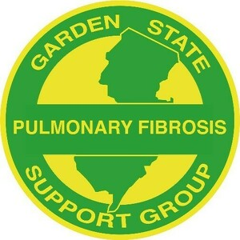
a 5013c Charitable Organization
Garden State Pulmonary Fibrosis Support Group
Meeting Agenda
Wednesday, February 23, 2022 @ 7 p.m. via Zoom

CALL TO ORDER

MOMENT OF SILENCE FOR MEMBERS WHO HAVE PASSED AWAY

VISION
To be a resource to those diagnosed with Pulmonary Fibrosis in order to educate patients and others about the disease and options for treatment; to offer hope, comfort and knowledge to patients, caregivers and their families and to raise funds in support of research to find effective treatments and a cure for this disease.

INTRODUCTION OF GUESTS
Charlie Bryant

GUESTS
Linda Hardy Respiratory Therapist at Cooperman Barnabas Medical Center
Erica Stuppler, LCSW at NBIMC

INTRODUCTION OF SPEAKER
Christine Williams

SPEAKER
Dr. Joshua Lee. Pulmonologist, Advanced Lung Disease and Transplant Center, Newark Beth Israel Medical Center, Newark, NY, “THE IMPACT OF DIAGNOSIS ON THE FAMILY”

FINANCIAL REPORT
Charlie Bryant

OLD BUSINESS
Meeting With Newark Beth Israel Medical Center Transplant Center, Treasurer, New Board Member, Oxygen equipment and accessories

PENDING BUSINESS
n/a

NEW BUSINESS
Donation to Johns Hopkins, Status Change of Leadership Team,

NEW MEMBER INTRODUCTIONS
- Jim and Kathy Cogan
- George & Meg Wolf
- John & Abigail MacKay
- Chris Shand

NON-TRANSPLANT MEMBER CHECK-IN*

TRANSPLANT MEMBER CHECK-IN*

FEBRUARY BIRTHDAYS/LUNG ANNIVERSARIES
n/a

NEXT MEETING DATE
Wednesday, March 23rd @ 7 p.m. via Zoom
ADJOURNMENT
*if time permits

