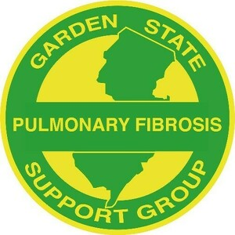
a 5013c Charitable Organization
Garden State Pulmonary Fibrosis Support Group
Meeting Agenda
Wednesday, July 27, 2022 @ 7 p.m. via Zoom

CALL TO ORDER

MOMENT OF SILENCE FOR MEMBERS WHO HAVE PASSED AWAY

VISION
To be a resource to those diagnosed with Pulmonary Fibrosis in order to educate patients and others about the disease and options for treatment; to offer hope, comfort and knowledge to patients, caregivers and their families and to raise funds in support of research to find effective treatments and a cure for this disease.

INTRODUCTION OF SPEAKER
n/a

SPEAKER
n/a

FINANCIAL REPORT
Laura Ocasio

OLD BUSINESS
- Dr. Vincent Valentine, Lung Transplant-Newark Beth Israel Medical Center
- Caregiver member to join Leadership Team

PENDING BUSINESS
- Volunteer Captains for the various jobs related to the October 5K

NEW BUSINESS
- 5K flyer
- QGive link

NEW MEMBER INTRODUCTIONS
n/a

NON-TRANSPLANT MEMBER CHECK-IN

TRANSPLANT MEMBER CHECK-IN

JULY BIRTHDAYS
- Guiseppina Ciccone: July 15th
- Barry Abel: July 28th
- Jean Chang (caregiver): July 4th
- Marie Bryant (caregiver): July 5th
- Wilfredo Toro (caregiver): July 14th
- Terri Holz (caregiver): July 19th

LUNG ANNIVERSARIES
- Ed Hardina: July 13, 2019
- Ed Sonnenberg: July 23, 2019

NEXT MEETING DATES
- August 31 (speaker), September 28 (members), October 26 (speaker), November 16th (Thanksgiving/member), December TBD
- Tuesday meetings: TBD

ADJOURNMENT

