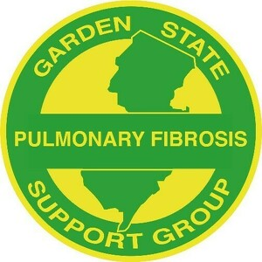
a 5013c Charitable Organization
Garden State Pulmonary Fibrosis Support Group
Meeting Agenda
Wednesday, November 30, 2022 @ 7 p.m. via Zoom

CALL TO ORDER

MOMENT OF SILENCE FOR MEMBERS WHO HAVE PASSED AWAY

VISION
To be a resource to those diagnosed with Pulmonary Fibrosis in order to educate patients and others about the disease and options for treatment; to offer hope, comfort and knowledge to patients, caregivers and their families and to raise funds in support of research to find effective treatments and a cure for this disease.

INTRODUCTION OF SPEAKER
n/a

SPEAKER
n/a

FINANCIAL REPORT
Laura Ocasio

PENDING BUSINESS
n/a

NEW BUSINESS
- Holiday party
- Updated brochure
- Annual donation to research/science
- 2023 meeting topics
- 2023 speakers
- Corporate donations (Benevity)
- Corporate Matching donations

OLD BUSINESS
5K discussion, Garden State Buddy

NEW MEMBER INTRODUCTIONS

NON-TRANSPLANT MEMBER CHECK-IN

TRANSPLANT MEMBER CHECK-IN

NOVEMBER MEMBER BIRTHDAYS
- Christine Williams: the 6th
- Laura Ocasio: the 8th
- Bayyinah Nashid: the 17th
- Ed Sonnenberg: the 29th

NOVEMBER CAREGIVER BIRTHDAYS
- Kathy Cogan: the 3rd
- Guiseppe Ciccone: the 9th
- Anne Hardina: the 17th
- Judith Abel: the 18th
- Elaine Weiss: the 22nd
- Lisa Raacke: the 28th

LUNG ANNIVERSARIES
- Rich Korczynski: November 10, 2016

OCTOBER MEMBER BIRTHDAYS
n/a

OCTOBER CAREGIVER BIRTHDAYS
- Mary Anne Kidon: the 1st

OCTOBER LUNG ANNIVERSARIES
- Alan Schwenk: October 6, 2009

NEXT MEETING DATES
- January 25, 2023
- Tuesday meetings: TBD

ADJOURNMENT

